***YHS Soccer Boosters Presents***

**Yorktown High School Soccer**

**SENIOR NIGHTS**

**Tuesday, May 18, 2021 (Girls)**

**Thursday, May 20, 2021 (Boys)**

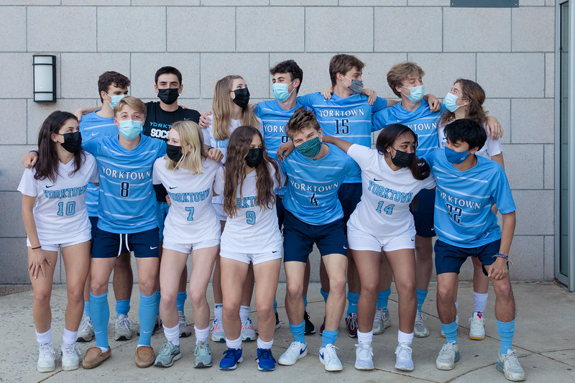

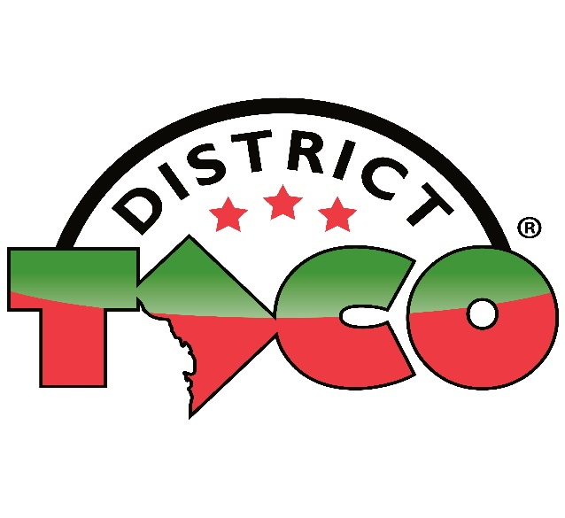 

**GIRLS VARSITY SOCCER SENIORS**

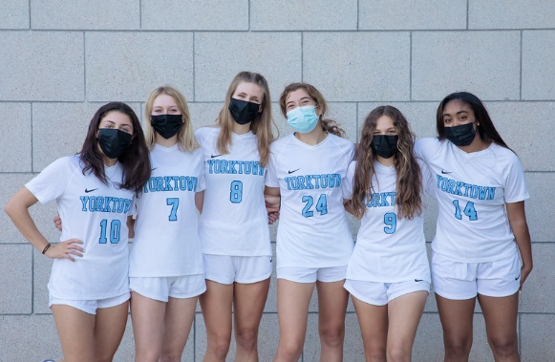

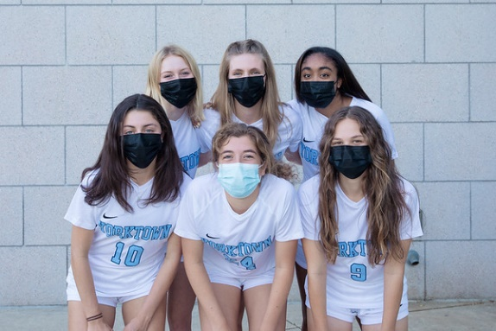

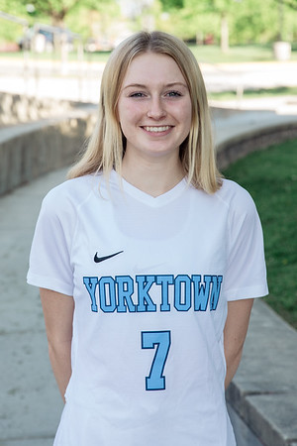

**Sarah W. (#7)**

Sarah’s favorite Yorktown soccer memory is winning 5-4 in overtime against McLean!

Next year, Sarah will be playing soccer at Colby College.

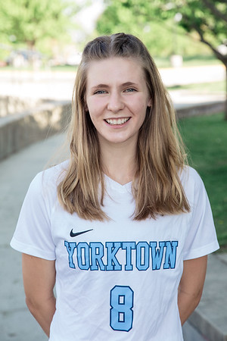

**Georgia B. (#8-Captain)**

Georgia’s favorite memory is going to team breakfasts and pasta dinners!!

She will be attending the University of Virginia and plans to major in public policy, pre-law track.

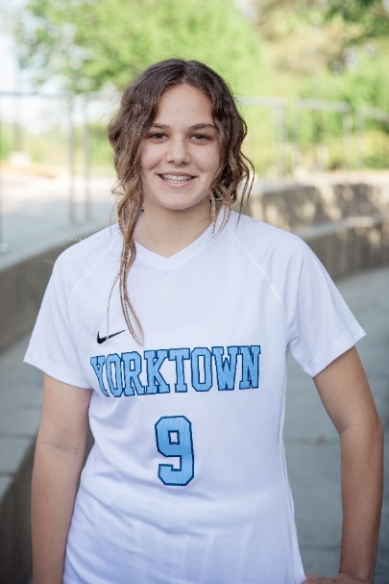

**Eliza F. (#9)**

Eliza’s favorite memory is jamming out to music before games and winning states sophomore year.

She will be attending the University of Mary Washington and will be playing soccer there.

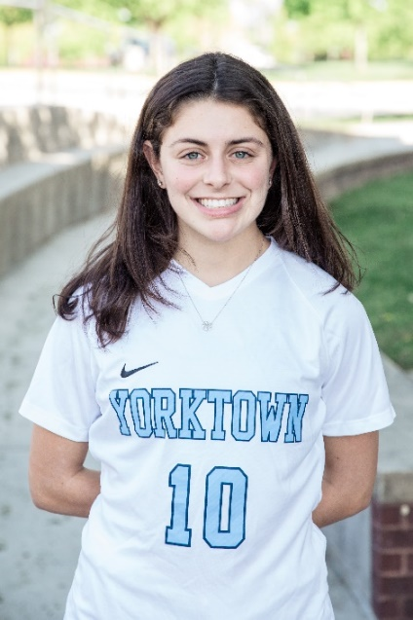

**Katy T. (#10-Captain)**

Katy’s favorite memory is winning states her sophomore year and celebrating with her teammates.

She is going to Davidson College to play Division 1 soccer and plans to study Sports Medicine.

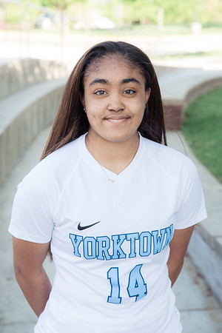

**Malina G. (#14)**

Malina’s favorite YHS memory has been being able to reconnect with all of the friends she grew up with as she is a recent transfer from St. John’s College High School. Next Year, she will be attending James Madison University to major in pre-med and minor in psychology. She is undecided about playing sports in college.

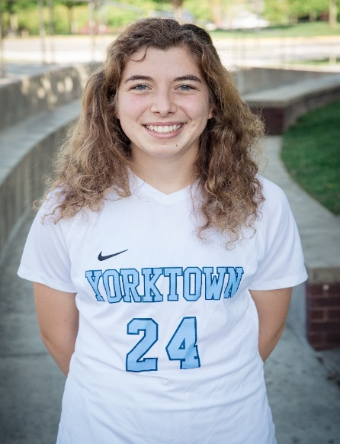

**Piper D. (#24-Captain)**

Piper’s favorite memory is bus rides to away games or getting bagels the morning of gameday.

She is attending Carleton College in the fall and playing soccer and running track.

**BOYS VARSITY SOCCER SENIORS**

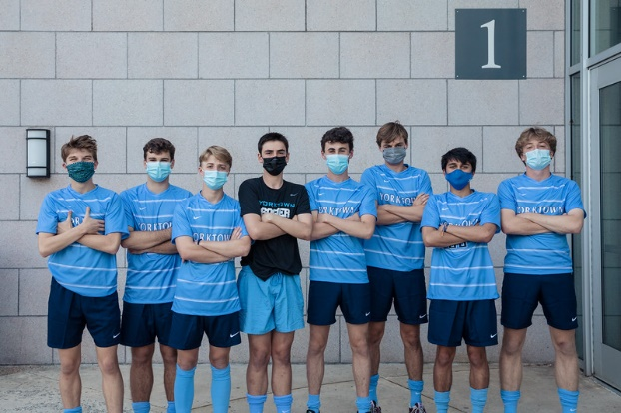

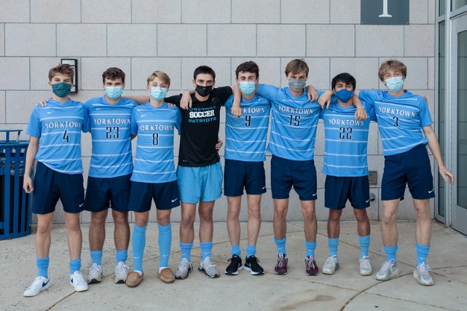

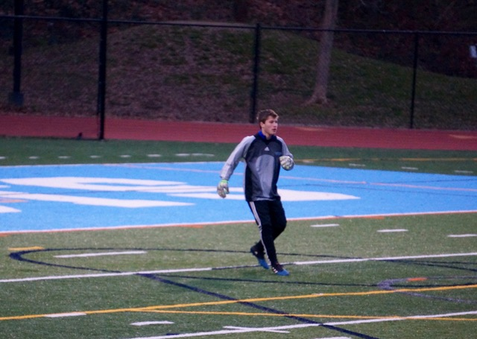

**Logan O. (#00-Goalie)**

Logan played goalkeeper for Yorktown for the past three years; his favorite memory is singing Veggie Tales on the soccer bus to away games freshman year. He plans to study Engineering at Wake Forest University.

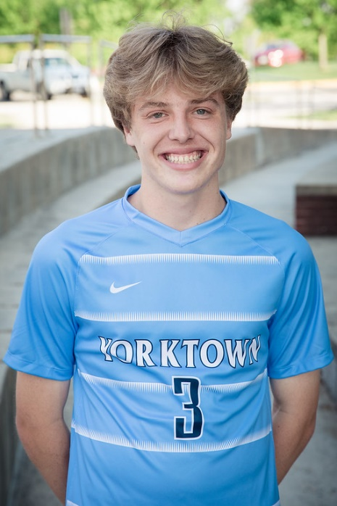

**Denny S. (#3)**

Denny’s favorite memory is bus rides to away games.

He is going to the University of Michigan and will be majoring in computer science.

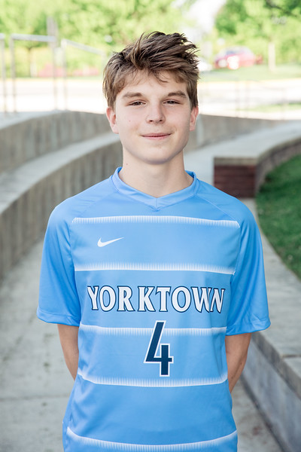

**John M. (#4)**

John’s favorite memory is scoring the winner against McLean.

He is attending Virginia Tech and Majoring in Early Education.

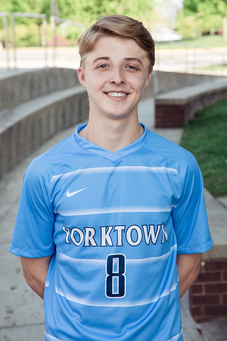

**Gibson L. (#8-Captain)**

Gibby’s favorite memory is riding the bus back with his homies after a win—and scoring the winning goal vs Langley is a cool recent memory! He is attending Clemson University and Majoring in Business.

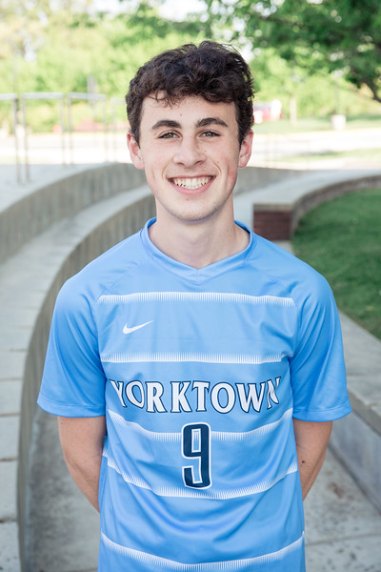

**Ben R. (#9)**

Ben’s favorite memory is the celebration with my teammates after scoring my first goal freshman year.

He will be majoring in biology at James Madison University.

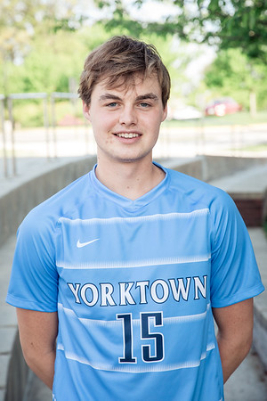

**Luke N. (#15-Captain)**  
Luke’s favorite memory is scoring the winning goal in a 1-0 win vs WL.  
He is going to the University of Virginia in the fall.

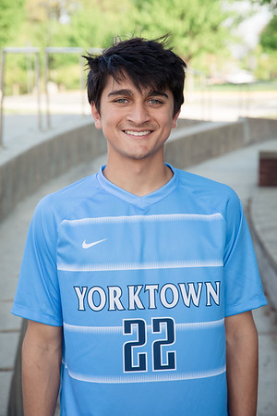

**Devin G. (#22)**

Devin’s favorite soccer memory is beating WL, 2 – 1 at home Freshman year.

He will be attending James Madison University and plans to play club soccer there.

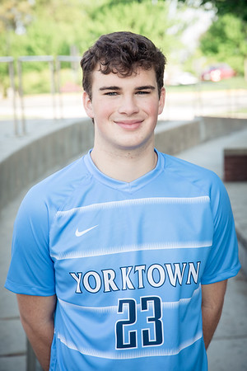

**Andrew D. (#23)**

Andrew’s favorite memory is playing his first varsity soccer game.

He will be attending James Madison University next year and plans on studying something related to business.

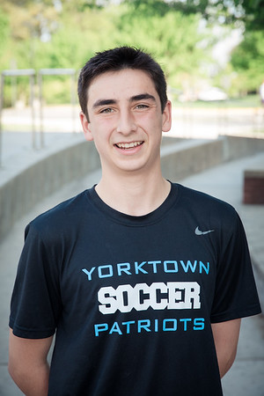

**Jackson H. (#28-Goalie)**

Jackson’s favorite memory is playing high school with friends who he met in Kindergarten--Luke, Denny, John and Logan. He will attend the University of Colorado-Boulder next year and plans to ski every weekend!

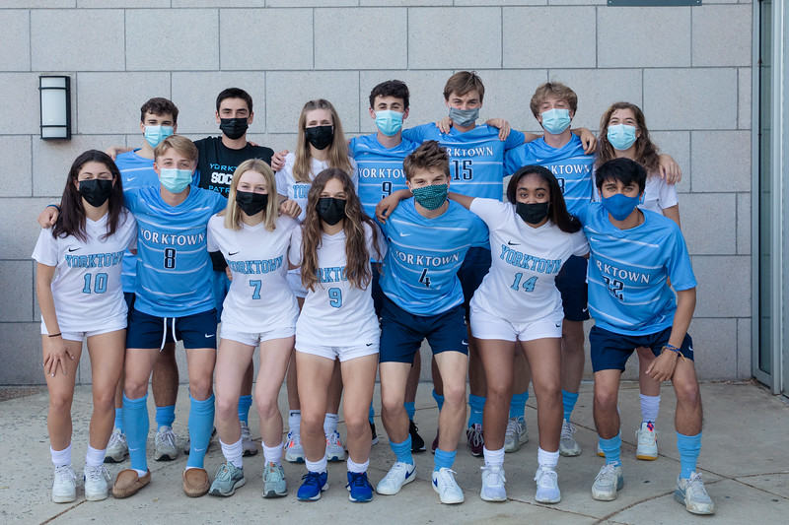

**SENIOR TRIBUTES**

Go Patriots! *Anonymous*

**Piper, Sarah** and **Eliza** – Good luck on the pitch in college. We know all of you will do great! *Anonymous*

Congratulations to all the YHS Seniors – thanks for a great season and good luck to you next year! *The Winer Family*

**Malina, Ben,** and **Andrew** – Good luck at JMU next year…the future is bright! *Anonymous*

Great work **Georgia**! We always love to watch you play! *Love, Mom, Dad, Sheridan and Maisy*

**Katy**, I’m so proud of you. You are a rock star in all things that you do and I can’t wait to see what you accomplish in years to come. You may be my younger sister but I look up to you in so many ways. Can’t wait to watch you do big things at Davidson! *Love you! Emily*

Congrats **Gibson**! *Love you bro, Garrett and Griffin*

**Devin,** good luck at JMU! We know you will shine in all you do! Our house will be lonely without D-E-G! *The Lusk Family*

**Denny, Logan, Luke, John** and **Jackson** – Wishing you all the best at college next year! We will miss your amazing personalities both on and off the field! *Anonymous*

**Katy**--You have put a smile on our face and joy in our hearts since the day you came into this world. Your intelligence, passion, hard work, and kindness are an inspiration to our entire family. You have accomplished a lot in 17 short years and we know there is so much more to come at Davidson and beyond. Keep shining! *We love you, Dad, Mom, Emily, Jessie, and Dasher 🐾*